Zoom Phone Sign in
Official URL: https://services.smsu.edu/TDClient/180/Portal/KB/Article/3971/Zoom-Phone-Sign-in
Category: Knowledge Base > Information Technology Services > Phones, Conferencing and Collaborations > Zoom Phone Sign in
Tags: zoom, phone, audio, call
_____________________________________________________

How to open and sign into your zoom phone on your computer
- Navigate to your zoom app on your computer and click on sign in
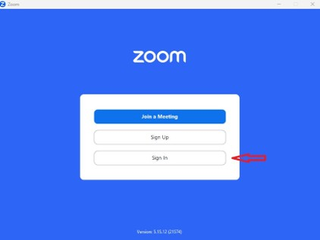
Figure 1: Zoom Phone sign‑in screen showing options to sign in with SSO or enter an email address
- Click on the SSO option
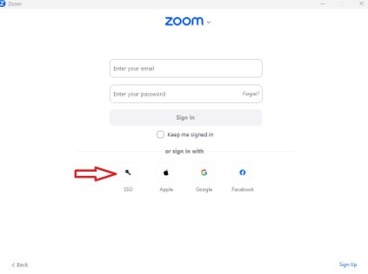
Figure 2: Zoom sign‑in screen with the ‘Sign in with SSO’ option selected.
- Type minnstate in the text box and click on continue
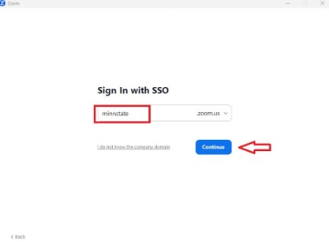
Figure 3: Zoom SSO domain entry screen with the organization domain set to ‘minnstate’.
- Sign in with your StarID@minnstate.edu or StarID@go.minnstate.edu and password.
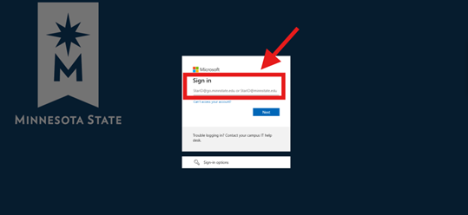
Figure 4: Minnesota State login page prompting for StarID and StarID password.
- Once you click on sign on, it will attempt to log you in via a web browser and the below screen shot will appear for you. Go ahead and click on open link to sign in your zoom app.
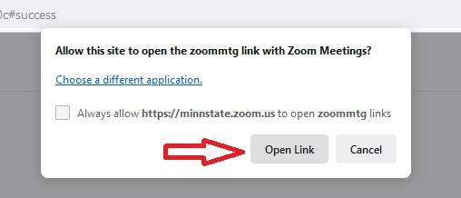
Figure 5: Browser dialog asking to allow the site minnstate.zoom.us to open a Zoom Meetings link, with options to open the link or cancel.
- Once you are signed into your zoom app, click on the phone tab
Figure 6: Zoom Phone application showing the phone control after successful sign‑in.

View additional Zoom Phone resources to learn more about features, setup, and troubleshooting.
Accessibility Review & Update Log:
- [x] Content accuracy and link integrity verified
- [x] High-contrast visual hierarchy implemented (Inter and Calibri)
- [x] Image alt-text captions verified (all screenshots captioned)
- [x] Outline headers and standard list sequences optimized for screen readers

